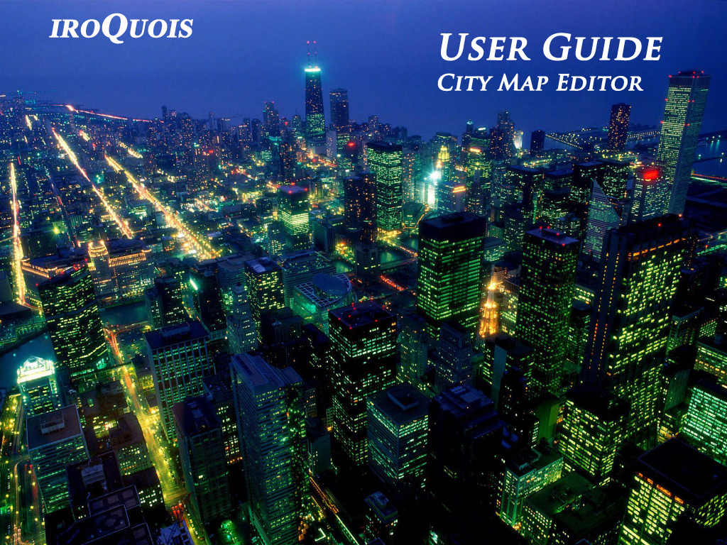

Table of Content Page

1. Introduction 4

1.1 Overview of City Map Editor features 5

1.1.1 City Map Editor Panel 7

1.1.2 Exit Program 7

1.1.3 Browser Panel 7

1.1.4 Google Map Search Bar 8

1.1.5 Depot Panel 8

1.1.6 Route Panel 8

1.1.7 Bus Stop Panel 9

1.1.8 Junction Panel 9

1.1.9 Traffic Light Panel 10

1.1.10 Save Map Panel 10

1.1.11 Existing Route Panel 11

1.1.12 Map (Local) Panel 12

1.1.13 Database Panel 13

1.2 Naming conventions used in this User Guide 14

1.3 System Requirements & Limitations 15

2. Map 16

2.1 Searching maps using Google Map Search Bar 17

2.2 Using map 18

2.3 Saving map 20

2.4 Loading saved map 21

2.5 Renaming saved map 22

2.6 Deleting a saved map 23

2.7 Uploading and Downloading from Database 24

2.8 Refreshing maps 28

2.9 Exiting the City Map Editor 29

3. Map Components 30

3.1 Add/delete depot(s) 31

3.2 Create/delete route(s) 34

3.3 Add/delete bus stop(s) 38

3.4 Add/delete junction(s) 40

3.5 Add/delete traffic light(s) 42

4. Application Example 44

5. Troubleshooting Tips 52

# Introduction

The City Map Editor is a java-based editor application that aims to create a user-friendly interface for users to create and edit routes on Google maps with much ease.

This user guide gives an overview of the functional features of the City Map Editor and highlights the step-by-step processes of implementing the various functions.

In this chapter, we will discuss the following topics:

* About getting started on the City Map Editor
* Overview of the available features of the City Map Editor
* The naming conventions that will be adopted in this user guide
* Provide system requirements of using the City Map Editor for optimal results

The entire user guide is segmented into different sections that cover the basic features of the City Map Editor. The goal of each section is to assist the user in understanding and applying the different features.

These sections do not replace and are not to be confused with the readme.txt file and the java documentations that come with the City Map Editor application. Detailed explanation and documentation on how to use the City Map Editor are provided in the tutorials only. Users will find that the tutorials can aid them better in learning how to use the City Map Editor.

## Overview of City Map Editor features

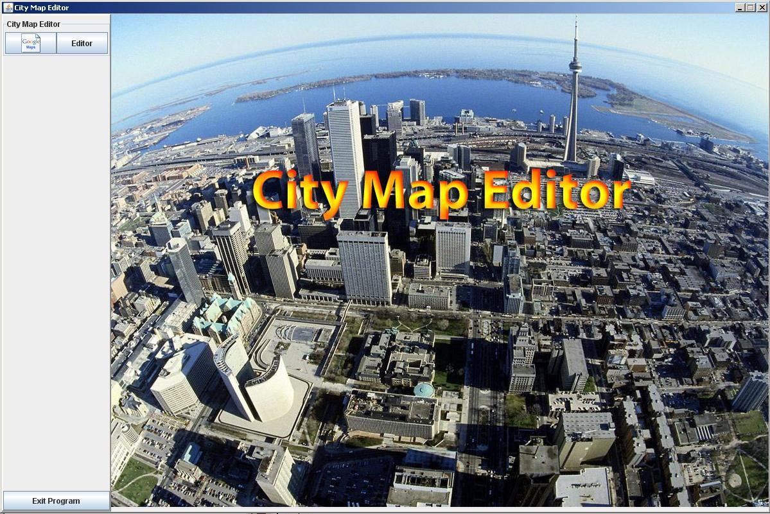

City Map Editor Panel

Exit

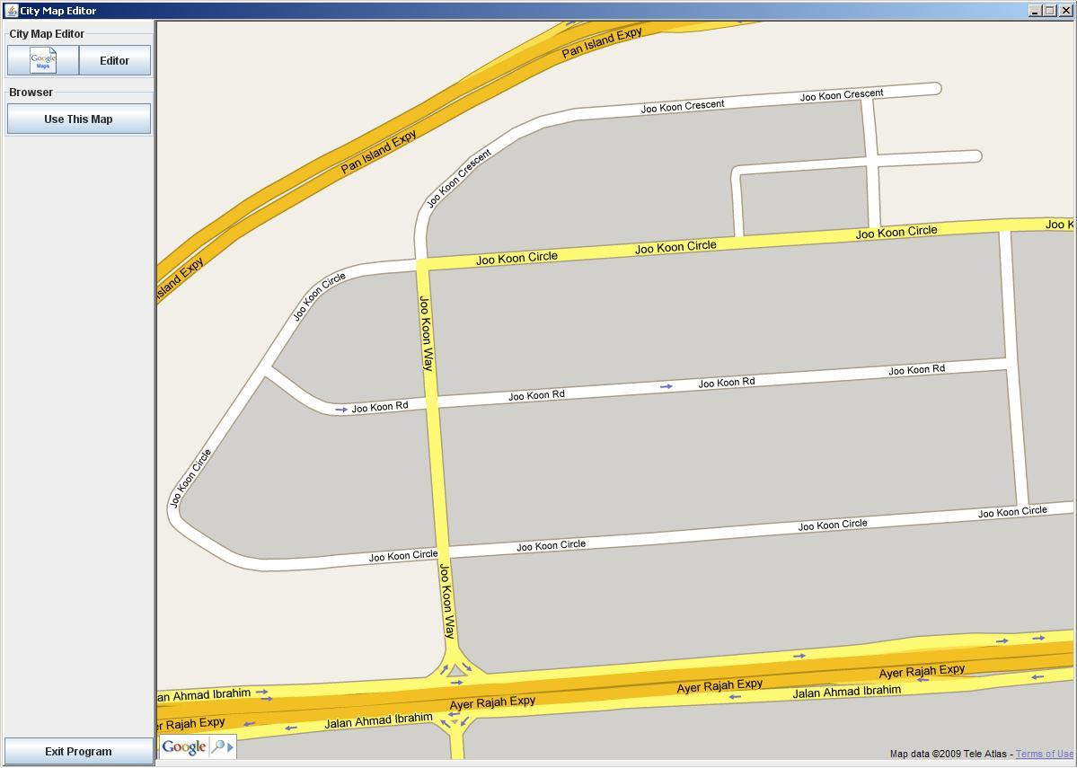

Browser Panel

Depot Panel

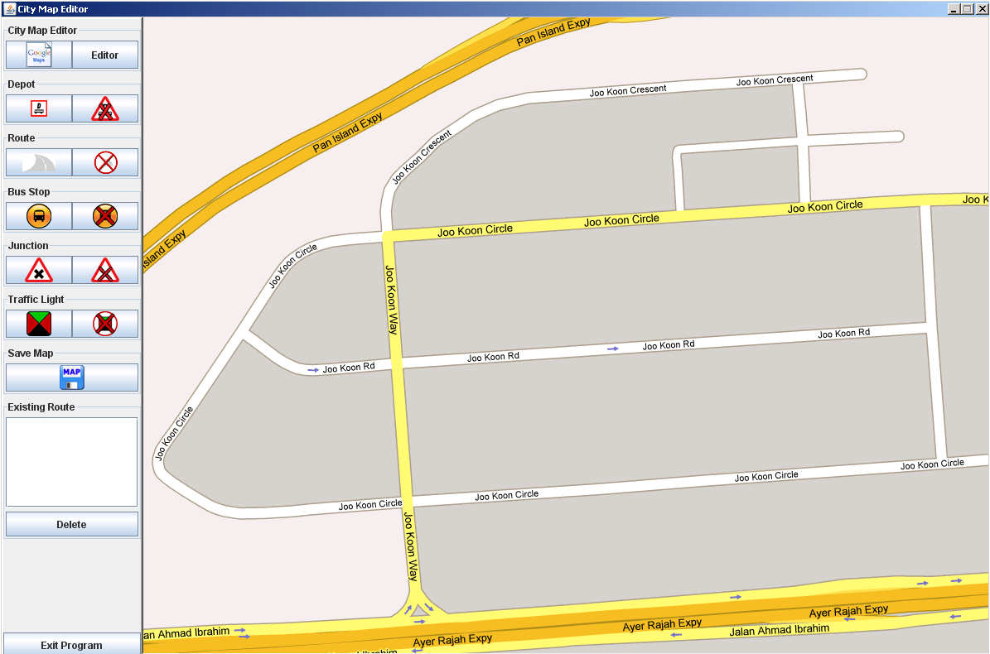

Traffic Light Panel

Junction Panel

Existing Route Panel

Save Map

Bus Stop Panel

Route Panel

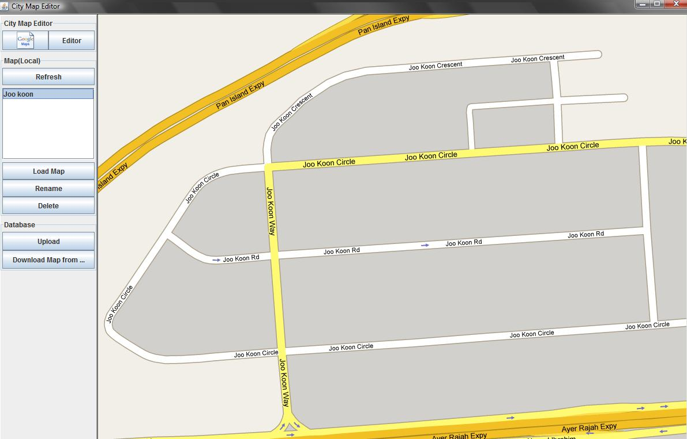

Database Panel

Map (Local) Panel

### City Map Editor Panel

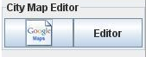 1. *Google Map button*:

1. Google Map

2. Editor

This button enables you to use a new map for the simulator after saving the previous map or making a new map.

2*. Editor button*:

This button enables you to enter the [Map (Local)] and [Database] panel.

### Exit Program

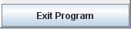 *Exit Program button*:

This button enables you to exit the program.

### Browser Panel

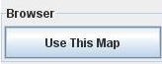 *Use This Map button*:

This button enables you to use the map selected to add features.

### Google Map Search Bar

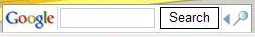 *Google Map Search Bar*:

The search bar enables you to search maps from all over the world.

### Depot Panel

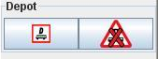 1. *Depot button*:

This button enables you to add depots to the off- road area of the map.

1. Add Depot

2. Delete Depot

2. *Delete Depot button*:

This button enables you to delete the selected depot from the map after insertion.

### Route Panel

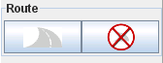 1. *Add Route button*:

1. Add Route

1. Delete Route

This button enables you to add the route for the Buses on the road of the map.

2. *Delete Route button*:

This button enables you to delete current route plotted in the case of having wrong plotting or changes of the plotting.

### Bus Stop Panel

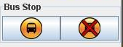 1. *Add Bus Stop button*:

2. Delete Bus Stop

1. Add Bus Stop

This button enables you to add Bus Stops to the off-road area of the map.

2. *Delete Bus Stop button*:

This button enables you to delete the selected Bus Stops on the map after insertion.

### Junction Panel

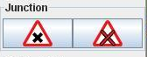 1. *Add Junction button*:

1. Add Junction

2. Delete Junction

This button enables you to add Junction icon on the junctions of the road in the map, allowing for detection of junctions for the program.

2. *Delete Junction button*:

This button enables you to delete Junction icon added on the map, disabling the detection of that particular junction.

### Traffic Light Panel

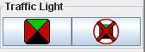 1. *Add Traffic Light button*:

2. Delete Traffic Light

1. Add Traffic Light

This button enables you to add Traffic Light on the junctions of the road in the map.

2. *Delete Traffic Light button*:

This button enables you to delete the added Traffic Lights.

### Save Map Panel

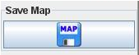 1. *Save Map button:*

1. Save Map

This button enables you to save the map that you created/edited.

### Existing Route Panel

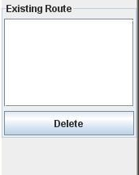 1. *Existing Route List Box*:

This List Box displays the route created and saved. Clicking on the text inside reveals the route.

2. Delete

1. Existing Route List Box

2. *Delete button*:

This button enables you to delete the saved route that shown on the Existing Route Text Box.

### Map (Local) Panel

1. *Refresh button*:

This button refreshes the panel and shows all the maps saved.

2. *Load Map button*:

This button enables maps to be loaded to the panel that were saved.

3. *Rename button*:

This button enables you to rename the name of the maps that were saved.

4. *Delete button*:

This button deletes the maps saved by first selecting the map that the user wants to delete, then click the delete button.

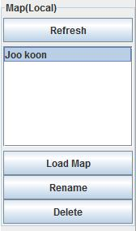

1. Refresh

2. Load Map

4. Delete

3. Rename

### Database Panel

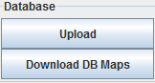 1. *Upload button*:

This button enables you to upload the maps saved to the Database. Doing this enables the Database and other systems to get the information and generates the simulation.

2. Download DB Maps

1. Upload

2. *Download DB Maps button*:

This button enables you to download the map from Database and make changes to the map according to your preference.

### 

## 1.2 Naming conventions used in this User Guide

Some important conventions used throughout the user guide are explained in this section.

The examples and screen illustrations within the user guide is consistent across the operating system.

The names of panels and buttons mentioned in the user guide will be in italic, for example, *Add Depot button.*

When instructions given to select a saved map, we use the following convention:

* **Menu** > **Object** > **Command** (for example **Editor** > **saved map** > **Load**)

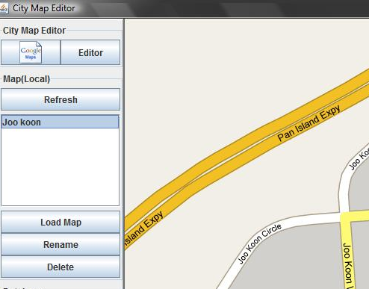

Object

Menu

Command

When instructions given to add a traffic light, we use the following conventions:

* **Menu** > **Object** > **Command > Component** (for example **Editor** > **saved map** > **Load > Add Traffic Light button**)

 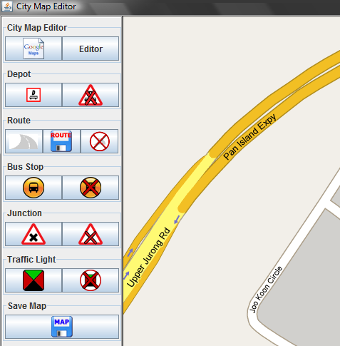

Object

Menu

Add Traffic Light

Command

## 1.3 System Requirements & Limitations

The City Map Editor application is software created using Java. Hence, there are several system requirements to be met in order for the software to work. Meeting these requirements ensures the City Map Editor application to have a smooth operation.

The City Map Editor application has the following requirements:

* Resolution of City Map Editor must be 1024 x 768 in order to fit on computer display.
* Uses 16-Bit medium color for projection.
* Must have internet access in order to use City Map Editor
* Set Internet Explorer as your default browser.

Important things to take note when using the City Map Editor:

* City Map Editor does not support maps with 3D buildings; it is 2D based software.
* Captures the screen shot of the Google Map, hence, relies on your platform performance to achieve great resolutions.
* Use of maps with lesser roads is recommended.
* Only 4 Depots are allowed to be placed on per map.
* Traffic Lights and Junctions are only allowed to be placed on junctions found in the maps and not on Expressway.
* Bus Stops and Depots can only be placed on off-road (side of road) and also not on Expressway.

# 2. Map

With the City Map Editor, you can create your own bus service system to model a realistic Bus Service System.

The City Map Editor enables you to simulate:

* How buses move.
* How different placement of bus stops and depot affect the bus traffic.
* How buses respond to junctions.

## 2.1 Searching maps using Google Map Search Bar

The Google Map Search Bar is interface which allows you to search any map on Earth. This enable you to access maps immediately and ensure the ease of use. The maps that you can find are what Google has up till now.

To start off, double click on **runCME.bat.**

After the program started, search an area of interest using Google Map Search Bar by selecting

**Google Map > Google Map Search Bar**

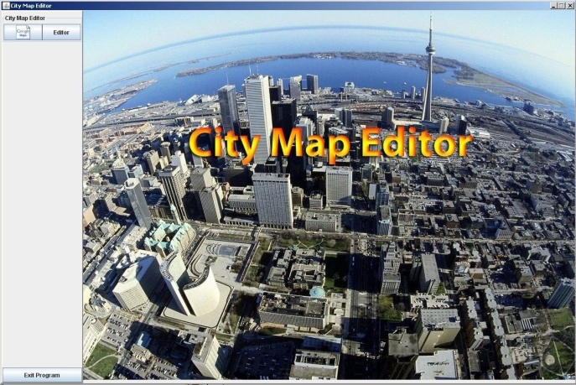 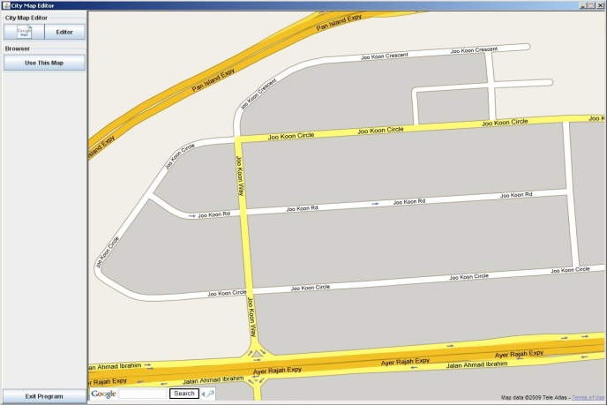

Type here

and type the name of the country that the map you wish to use. To find an extact location, type in thefollowing format **Name of the Street > Name of City > Name of Country** and click on **Search**.

If the location of the area of your interest is near the location shown on the display,

1. Move your cursor to the map and the cursor should change to a “hand”  icon.
2. Click and hold your mouse and move your mouse.
3. Release your mouse after you have finding the area of your interest.

The following picture shows the changes of the map before moving and after moving of the map.

## 2.2 Using map

To use a map,

Type Here

1. Select **Google Map > Google Search Bar.**

2. Type in the name of the area of the interest 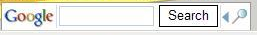and click **Search**.

3. Click on 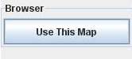 in the **Browser Panel** and you will be prompt to enter **Map ID**, which is the name/ID of the map as in the picture.

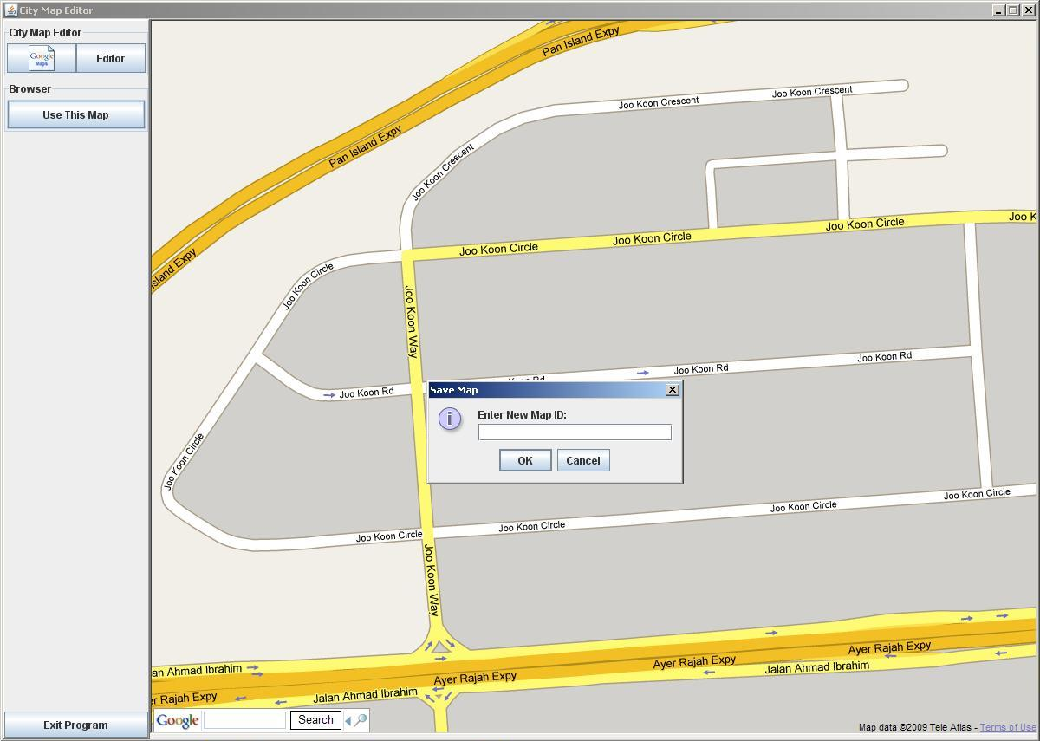

4. Enter the name/ID and click on **OK**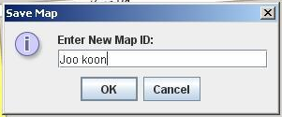 . You will be brought to next screen**:**



If the text box is empty and the **OK** button is clicked, an error message will be displayed and you have to type the name/ID again.

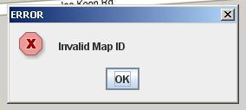

**Note:**

It may take some time to wait for the map to be shown on the screen after entering the name/ID for the map and click **OK**. This is due to the time needed to retrieve the map from the internet.

## 2.3 Saving map

Saving the map allows you to work on the map that you have created/edited.

To save a map,

1. Click on the **Save** button once you have done adding the components for the simulation. City Map Editor places a message box, ready for your confirmation.

2. Click on **OK** button.

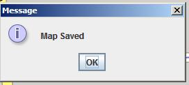

3. If you are working on a map that was saved previously, a replace message will be placed for your confirmation.

4. Click on the **Yes** button if you want to replace the map. Click on **No** if you want to make some necessary changes or you do not wish to replace the map.

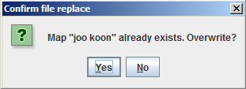

After saving the map, click on 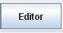 and you will be brought to the following screen:

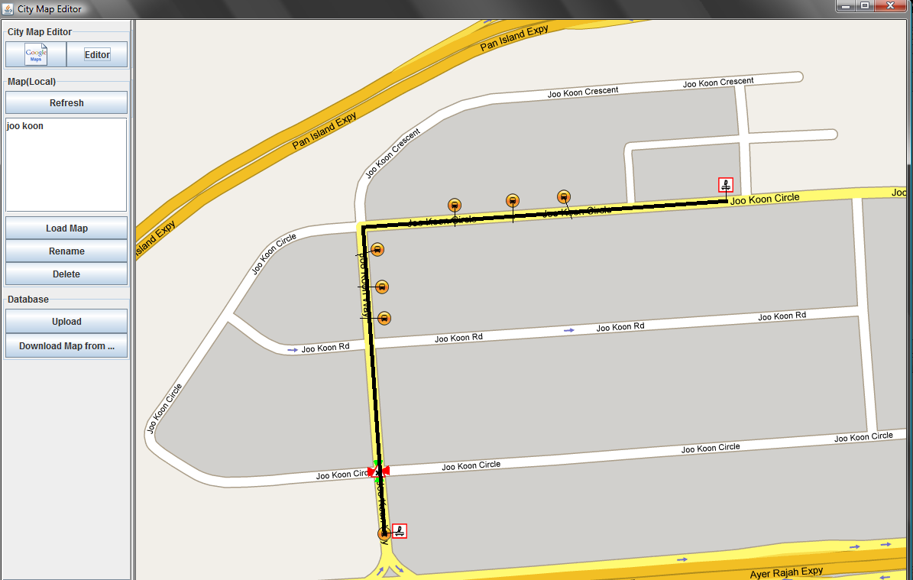\

Map name

## 2.4 Loading saved map

Loading of maps that you saved allows you to do various operations like editing and renaming of the maps.

To load a saved map,

1. Click on  and changes will be made for the sidebar as shown in the picture:

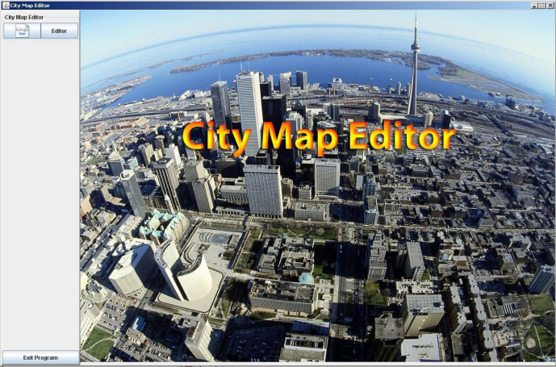 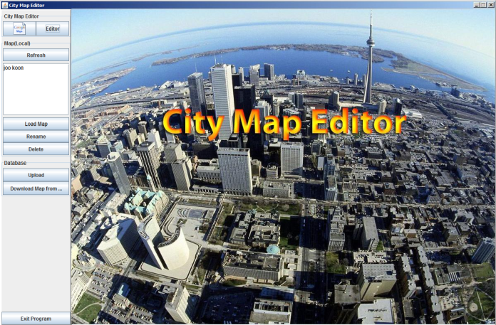

2. Select the map in the **Map (Local)** text box.

3. Click on the **Load Map** button.

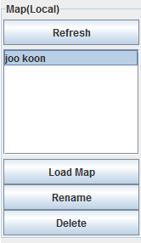

This will then brings you to the map that you selected and you can start working on the map.

## 2.5 Renaming saved map

Renaming a saved map allows you to rename your map for purposes such as for easy identification allowing your map to have a unique name/ID.

To rename your map,

1. Click on.

2. Select the map you wish to rename from **Map (Local) Panel** and click **rename.**

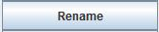

If a map is not selected, an error message will be displayed:

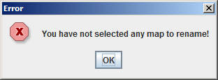

3. Type in the name that you wish to be names for the map and click **OK**.

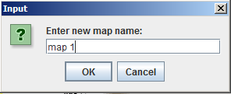

If the name that you wish to have exist in the **Map (Local)** text box, the following message will be shown:

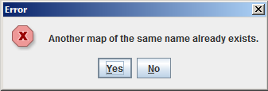

Click **Yes** to confirm.

## 2.6 Deleting a saved map

Deleting a saved map is a common practice, allowing necessary maps to be on the PC and discard the redundant ones.

To delete a saved map,

1. Click on.

2. Select the desired map to delete from **Map (Local)** button and click.

## 2.7 Uploading and Downloading from Database

The City Map Editor allows the creation and edition of maps. To be able to use the maps as a simulation, you will need to upload the maps to the Database.

To upload a map,

1. Click on.

2. Select the map from **Map (Local) Panel**.

3. Click on.

The following message will be displayed upon clicking the **Upload** button:

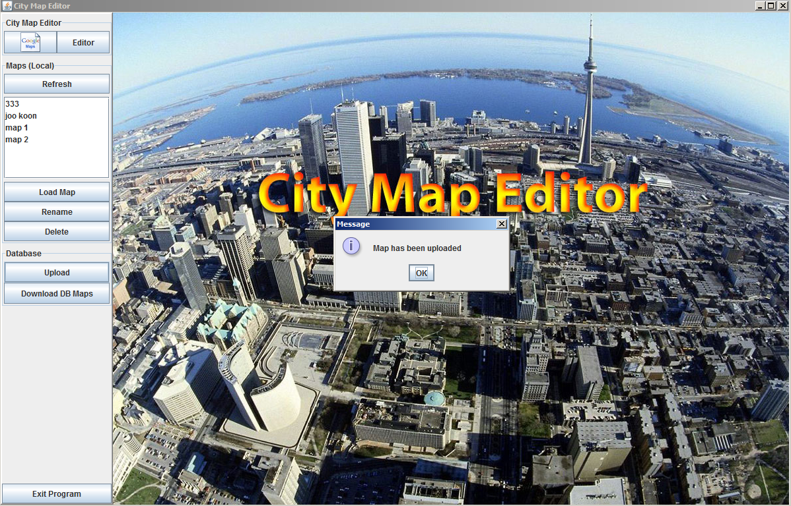

4. Click **OK** to complete the Uploading.

If the maps could not be uploaded, following message will be displayed:

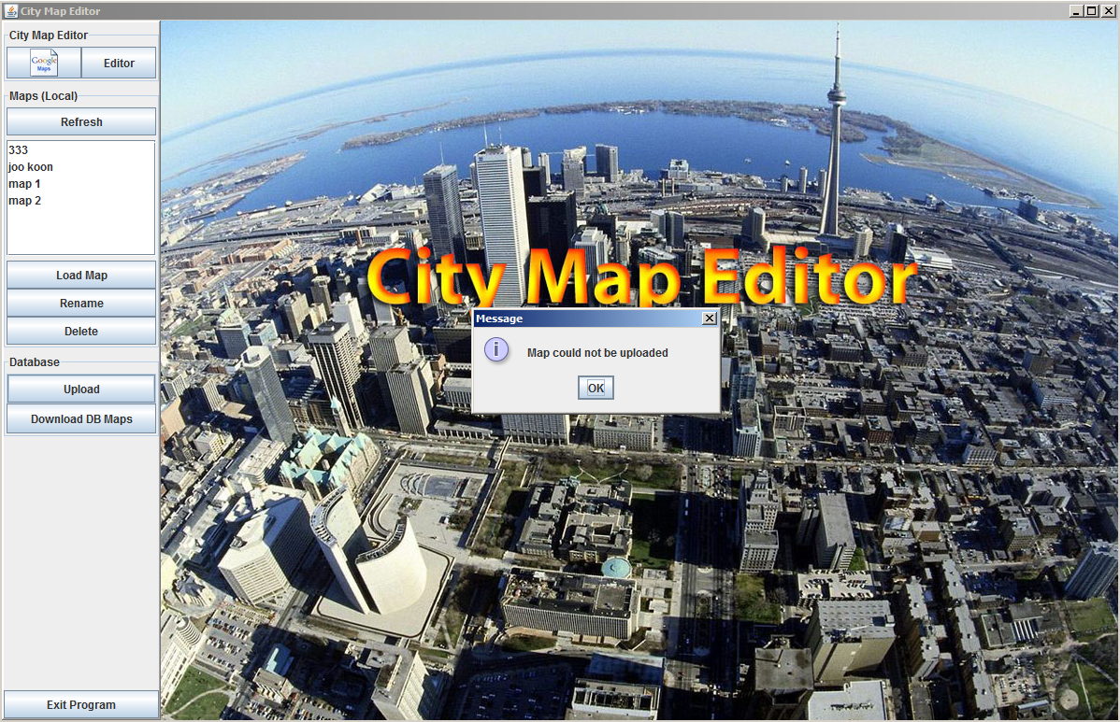

Unless you are connected to internet or Database is working fine, the message above will be displayed.

**Note:**

Uploading of your maps with the names same as the maps stored in the Database will result in overriding the maps in Database. To avoid such situation, ensure uniqueness to your map names.

The **Downloading Map from Database** button allows you to download the maps that you have uploaded to the Database and make changes to the maps according to your preference.

To download a map,

1. Click on.

2. Select the map from **Map (Local) Panel**.

3. Click on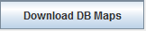.

If the name of the maps in Database matches the names of the maps you have in the **Map (Local) Panel** text box, the following message will be displayed:

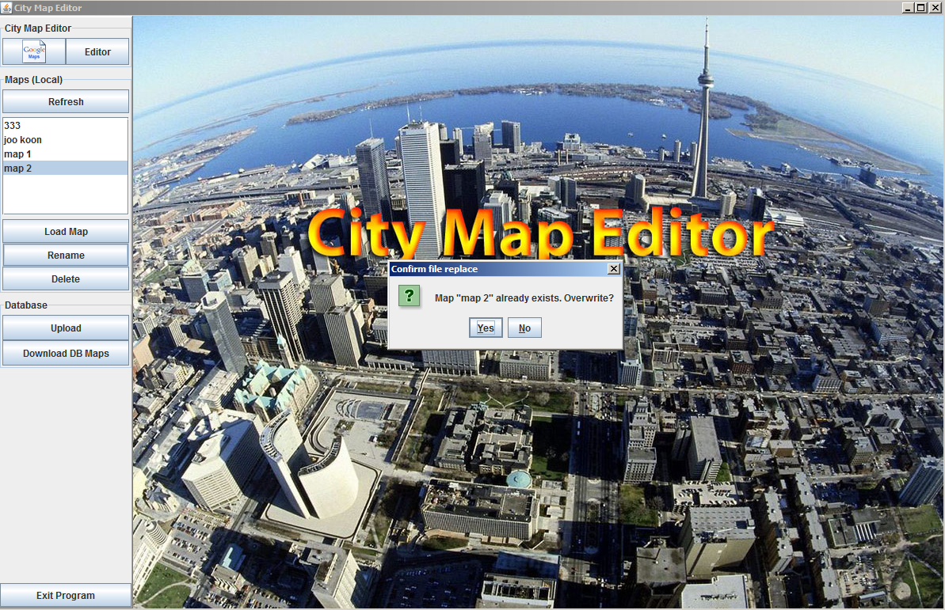

4. Click **Yes** to override and **No** to download with different names.

If you are not connected to internet, the following message will be displayed:

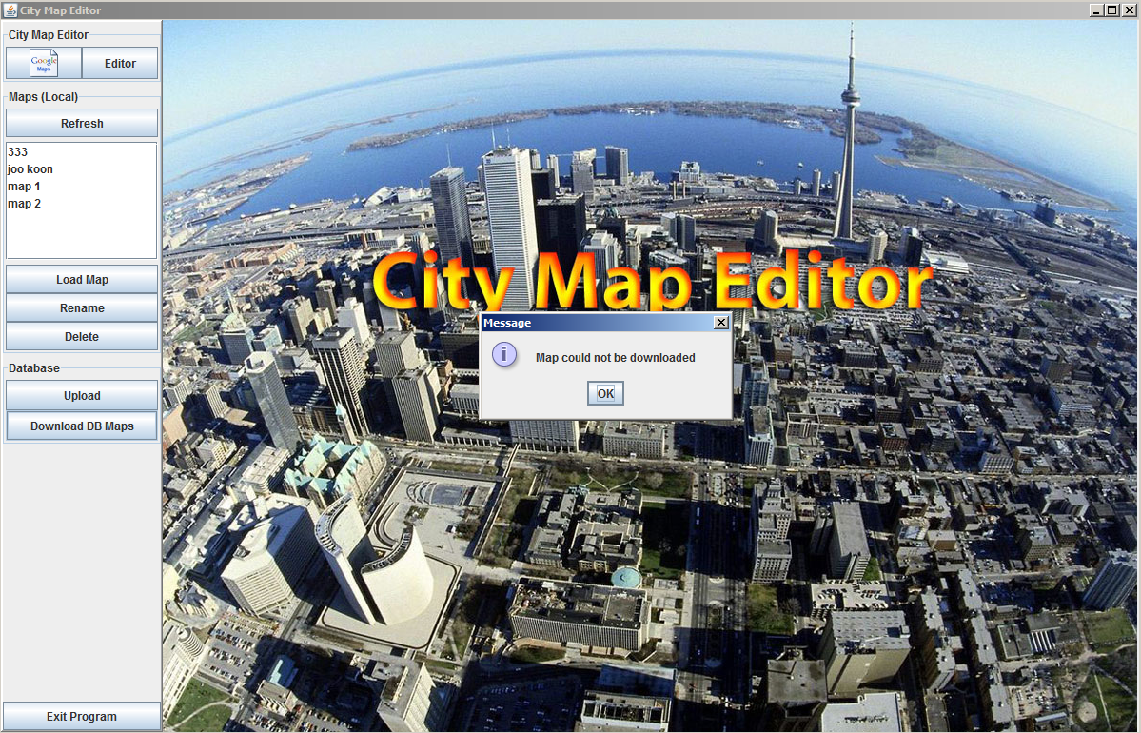

Click **Ok** and check your internet connectivity.

## 2.8 Refreshing maps

**Refresh** button allows the maps that are on your PC to be displayed on **Map (Local) Panel** text box. Maps on your PC are those that you have saved or downloaded from the Database.

To refresh the maps, select

**Editor > Refresh**

After refreshing, maps that are on your PC will be shown. The picture illustrates the result.



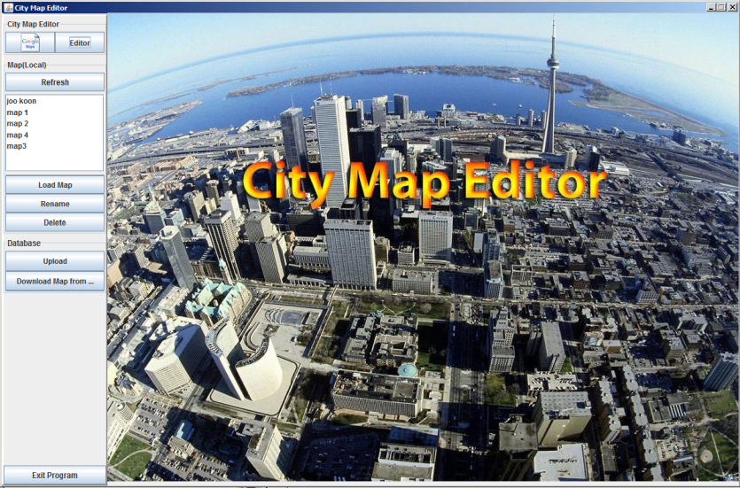

## 2.9 Exiting the City Map Editor

The **Exit Program** button allows you to exit the City Map Editor once you have done working on the maps.

To exit City Map Editor,

1. Click on 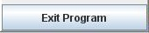 and you will be prompted with the following message:

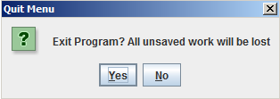

1. Click **Yes** to confirm, **No** to cancel the operation.

**Note:**

All unsaved work in your PC will be lost if you choose to exit the program. Always save your work once done. It is also a good practice t0 upload maps to database once you are done.

# 3. Map Components

The previous section discusses about the various map operations that is available for the user to use. In this section, users will learn about how to manipulate the map components that is available in the City Map Editor application.

Users can now add depots, bus stops and even create their designated routes on any Google maps. Junctions and traffic lights can also be specified on the maps to give the map route a more realistic presentation.

By applying the map functions listed in the previous section, and implementing the various map components as mentioned above, users will be able to customize their maps with different routes marked out on them with minimal effort.

## 3.1 Add/delete depot(s)

The *Depot Panel*, as shown below, is also mentioned in section 1.1.5.

This panel has two buttons, namely the *Add Depot button* and the *Delete Depot button*.

Depot Panel

Important Note (1):

Creating a depot is the most important step because it is a prerequisite step to create a route. Without a depot, routes cannot be added onto the map. A maximum of 4 depots can be added on one map.



2. Delete Depot

1. Add Depot

To add a depot,

Important Note (2):

A depot must be connected to a road. No depot can be added onto any non-road terrain.

1. Click on the *Add Depot button*.
2. Place your mouse cursor about 0.5cm above

the position that you want to place the depot

and click on it once.

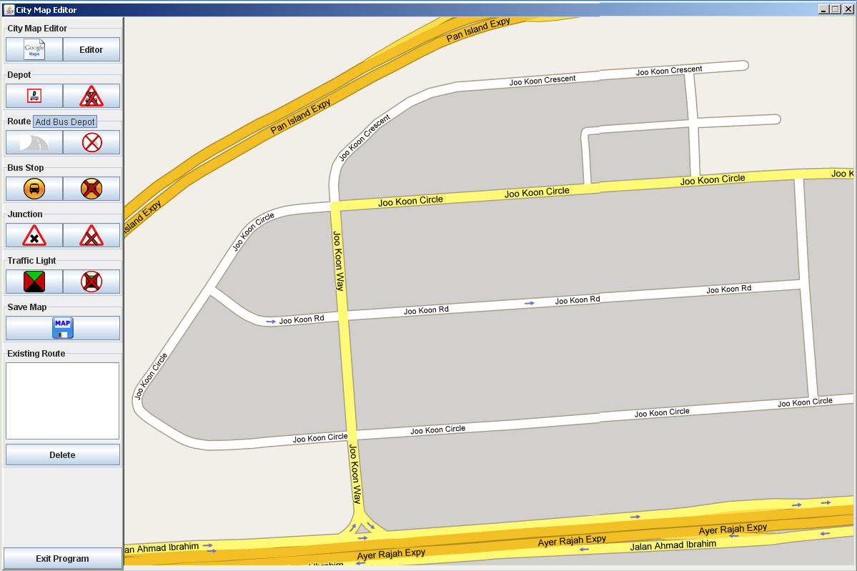

A depot will appear as shown in the following. The position of the line branching from the depot symbol to the road indicates the starting or ending position of the route.

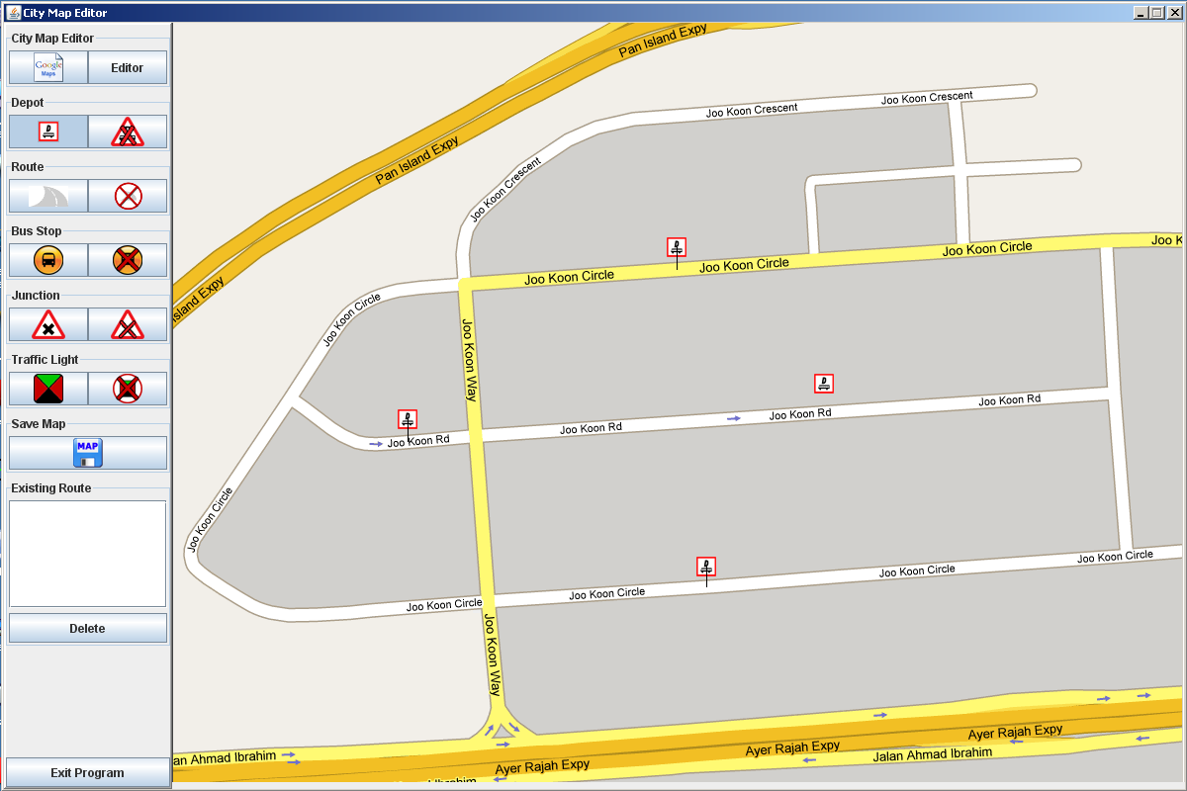

1. Repeat Step 1 to 2 to place the remaining 3 depots.

To delete a depot,

1. Click on the *Delete Depot button*.
2. Place your mouse cursor on the depot that you want to remove from the map and click on it once.

The depot will be removed permanently as shown below.

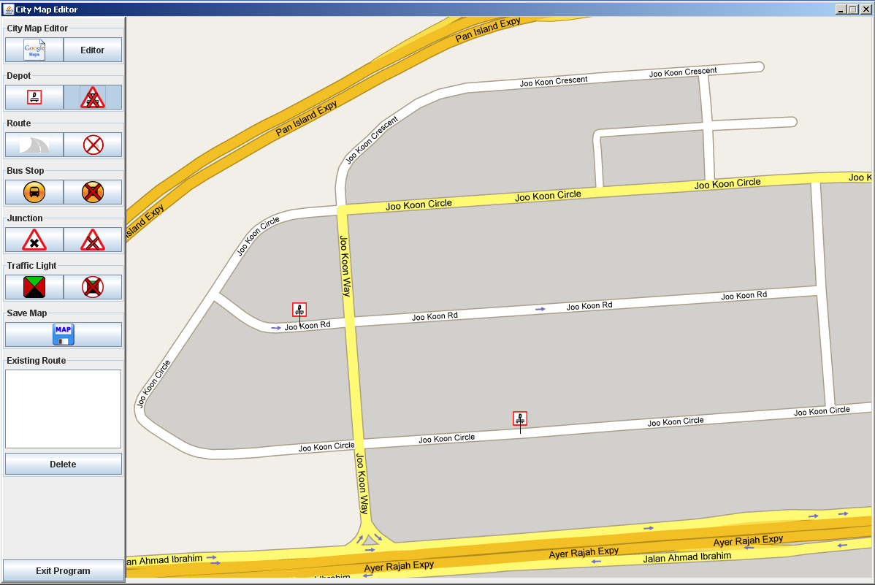

1. Repeat Step 1 to 2 to remove the other depots. You can choose to add a new depot after you have deleted one. The maximum of depots that can be on a map is 4.

## 3.2 Create/delete route(s)

To create a route, we will need to make use of the *Route Panel* and the *Existing Route Panel*. These two panels are introduced in section 1.1.6 and 1.1.11 respectively.

The *Route Panel* and the *Existing Route Panel* is as shown in the following.

Route Panel Existing Route Panel





1. Add Route

2. Delete Route

Important Note (1):

Check to ensure that the depots are already added on the map. Then you can proceed to create routes on your map.

1. Existing Route List Box

2. Delete

To create a route,

1. Click on the *Add route button*.
2. A dialog will prompt you to enter the name of the route. Select OK after you have keyed in the route name.
3. Place your mouse cursor on the depot where you want your route to begin from and click on it once.
4. You will see that a line will appear, linking the mouse cursor to the depot. This is the starting point of the route.

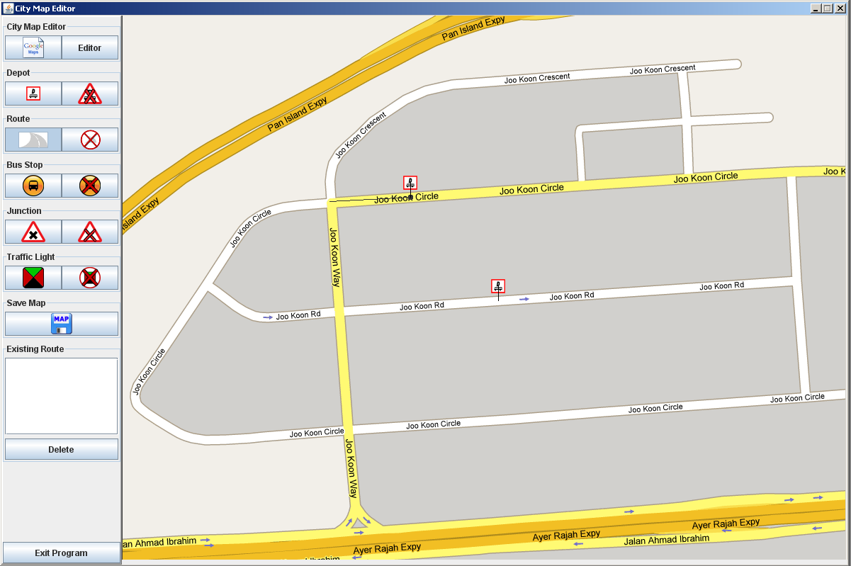

1. Continue to click on the different positions of the road

Important Note (2):

Routes can only be added on the road. Do not click too close to the edge of the road or non-road terrains for better efficiency.

which you want your route to cover. To place a route

that navigates a turn, you must click on the road before

the turn, and slowly click on the curved path until the

road is a straight path again.

1. To mark the end of a route, click on a depot.

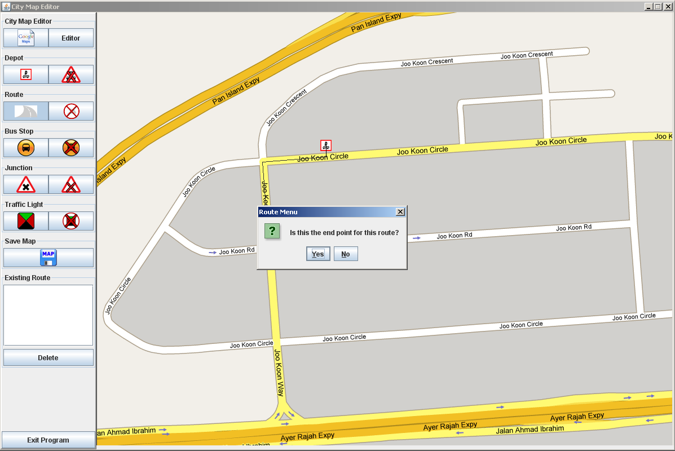

1. The resultant route will be highlighted as depicted.

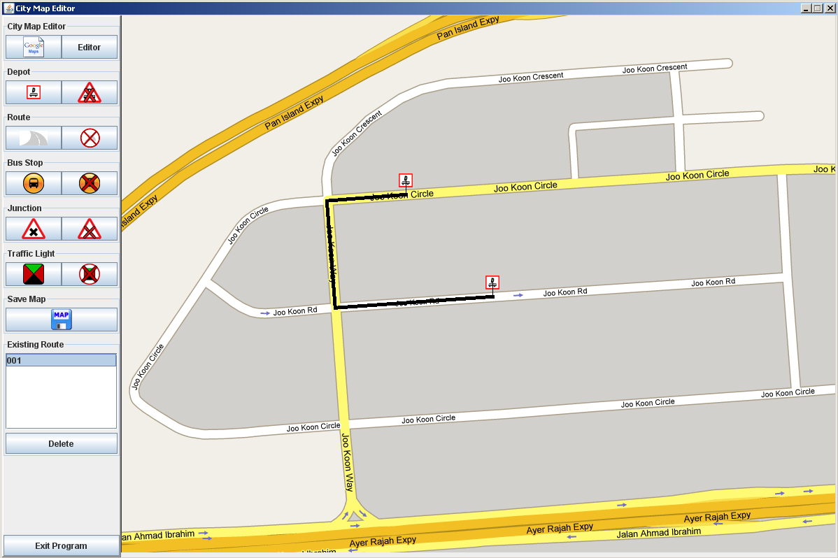

1. Repeat Step 1 to 6 to create more routes.
2. Click on *Save Map button* (listed in section 1.1.10) to save the changes made. You can create many routes before saving the map. However it is recommended to save the map after adding a route, in the event that the application experienced an exception error, or if the application hangs and has to be terminated.

Important Note (3):

Save the changes you have made frequently, in the event the application terminates or hangs due to exception or inactivity.

To delete an existing route,

1. Click on the *Delete Route button*.
2. After that, click on the route that you want to delete. From the diagram below, you will see that the route is removed permanently.
3. Alternatively, in the Existing Route box, select the name of the route that you wish to remove.
4. After selecting the name, click on the Delete button. The route name will be removed permanently. Both methods achieve the same effect.

## 3.3 Add/delete bus stop(s)

The City Map Editor application allows the user to indicate the location of the bus stops on the map by adding bus stop symbols. It facilitates the placement of routes as users can remember which route will reach a certain bus stop.

Important Note (1):

To add a bus stop symbol, users must click on a road terrain. Clicking on non-road terrain will not yield any result.

Bus Stop Panel



1. Add Bus Stop

2. Delete Bus Stop

Important Note (2):

The City Map Editor allows users to place as many bus stops symbols as they desired on one map.

To add a bus stop symbol,

1. Click on the *Add Bus Stop button*.
2. Place your mouse cursor on the location which you want to place the bus stop and click on it once. You must click 0.5cm above the road and a bus stop symbol will be shown; The City Map Editor application does not allow placement of bus stop on non-road terrains. The bus stop symbol will appear on top of the road location that is pressed shown in the following.

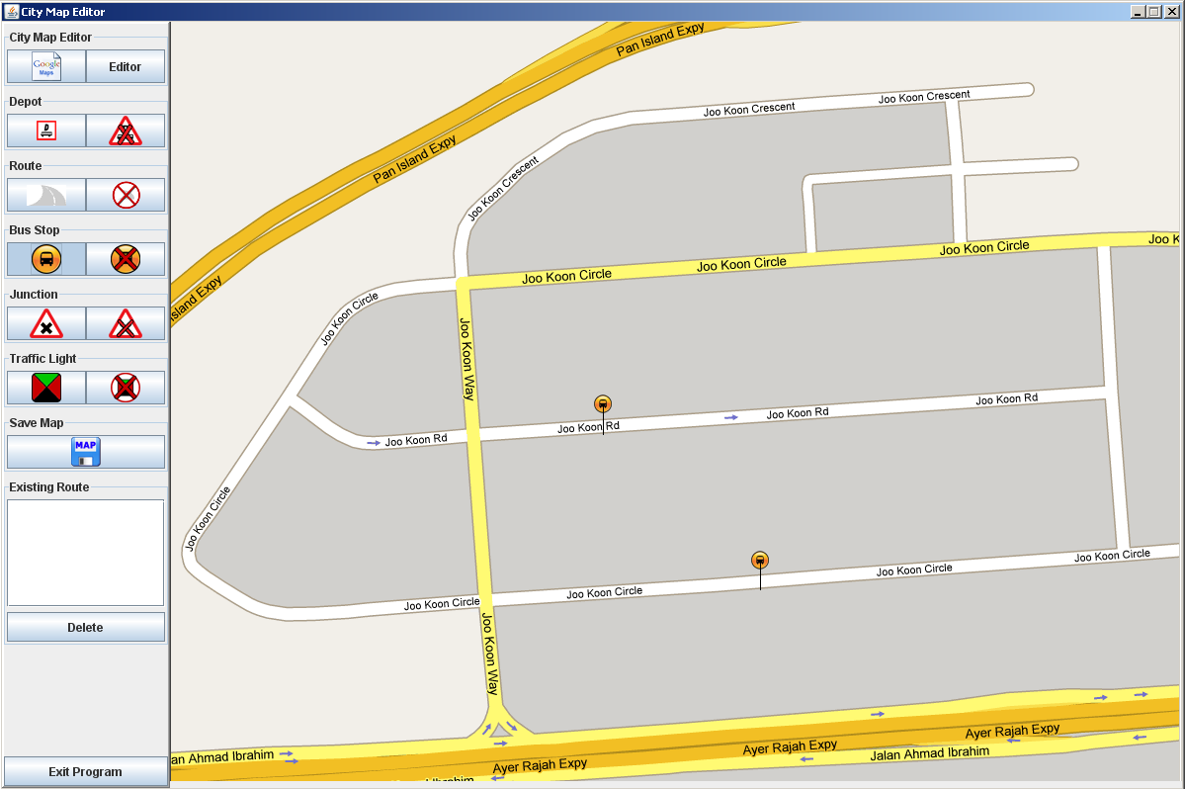

1. Repeat Step 1 and 2 to place more bus stops symbols.

To delete a bus stop symbol,

1. Click on the *Delete Bus Stop button*.
2. Place your mouse cursor on the specific bus stop symbol that you wish to delete and click on it once. That bus stop symbol will be removed permanently from the map.
3. Repeat Step 1 and 2 to remove more bus stops.

## 3.4 Add/delete junction(s)

Besides adding bus stops, the City Map Editor has the Add/Delete junction feature that allows the user to mark out the junctions that are shown on the map. This feature helps to highlight the junctions that appear in the map.

Important Note (1):

The City Map Editor allows users to highlight as many junctions as they wish. This feature can highlight any form of road junctions, for instance, cross junctions or T-junctions.

The Junction Panel



1. Add Junction

2. Delete Junction

Important Note (2):

To add a junction, clicking on any non-junction road or non-road terrains will not yield any result.

To add a junction symbol,

1. Click on the *Add Junction button*.
2. Place your mouse cursor on the junction that you wish to be highlighted and click on it once. You will notice that the junction symbol will be shown on the selected road junction.

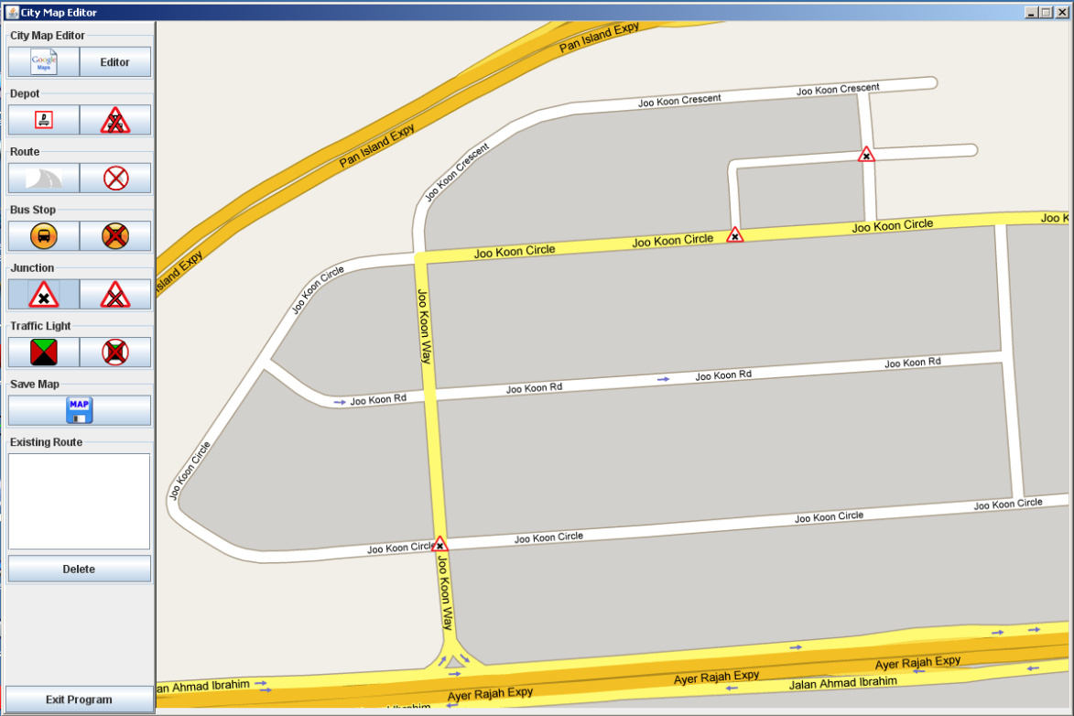

1. Repeat Step 1 and 2 to highlight more road junction symbols.

To delete a junction symbol,

1. Click on the *Delete Junction button*.
2. Place your mouse cursor on the specific junction symbol that you wish to delete and click on it once. That junction symbol will be deleted permanently.
3. Repeat Step 1 and 2 to delete more road junction symbols.

## 3.5 Add/delete traffic light(s)

The City Map Editor also allows the user to indicate the location of the traffic lights on the map by adding traffic light symbols. This feature facilitates the placement of routes as users can make informed choice of which route to take in the event if the user wishes to plan a route with minimal traffic light to reduce travelling time.

Important Note (1):

To add a traffic light symbol, users must click on a road junction. Clicking on non-road terrain or non-junction roads will not yield any result.

Traffic Light Panel



1. Add Traffic Light

2. Delete Traffic Light

Important Note (2):

The City Map Editor allows users to place as many traffic light symbols as they desired on one map.

To add a traffic light symbol,

1. Click on the *Add Traffic Light button*.
2. Place your mouse cursor on the junction that you wish to add the traffic light symbol and click on it once. The traffic light symbol will be added on the particular junction as shown in the following.

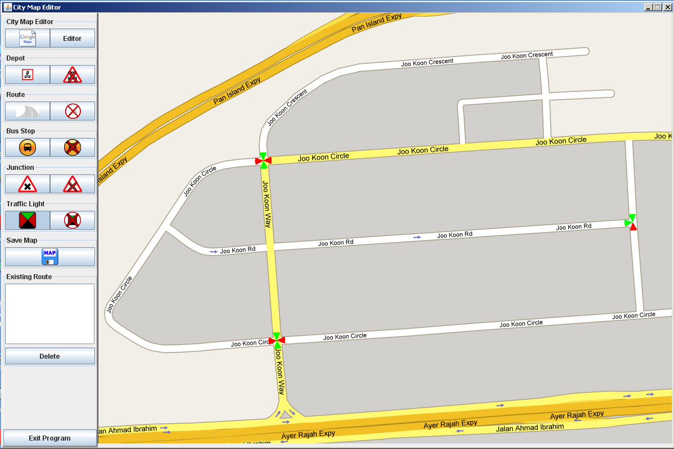

1. Repeat Step 1 and 2 to add more traffic light symbols.

To delete a traffic light symbol,

1. Click on the *Delete Traffic Light button*.
2. Place your mouse cursor on the specific traffic light symbol that you wish to delete and click on it once. That traffic light symbol will be removed permanently.
3. Repeat Step 1 and 2 to delete more traffic light symbols.

# Application Example

This section includes a detailed step-by-step example on how to make use of the City Map Editor application to create and customize a Google map by adding depots, routes, bus stops, junctions and traffic lights.

Users are encouraged to refer to this section if they encounter any problems in using the City Map Editor application. Alternatively, users can refer to the Frequency Asked Question (in section 5) for more information on some of the common problems encountered in using the application.

Case Problem:

User X wishes to place a route on the Joo Koon map to get to Joo Koon Cresent from Joo Koon Circle.

Steps to take:

* First of all, double-click on the MS-DOC batch file named CME.bat. Wait for the application to load.

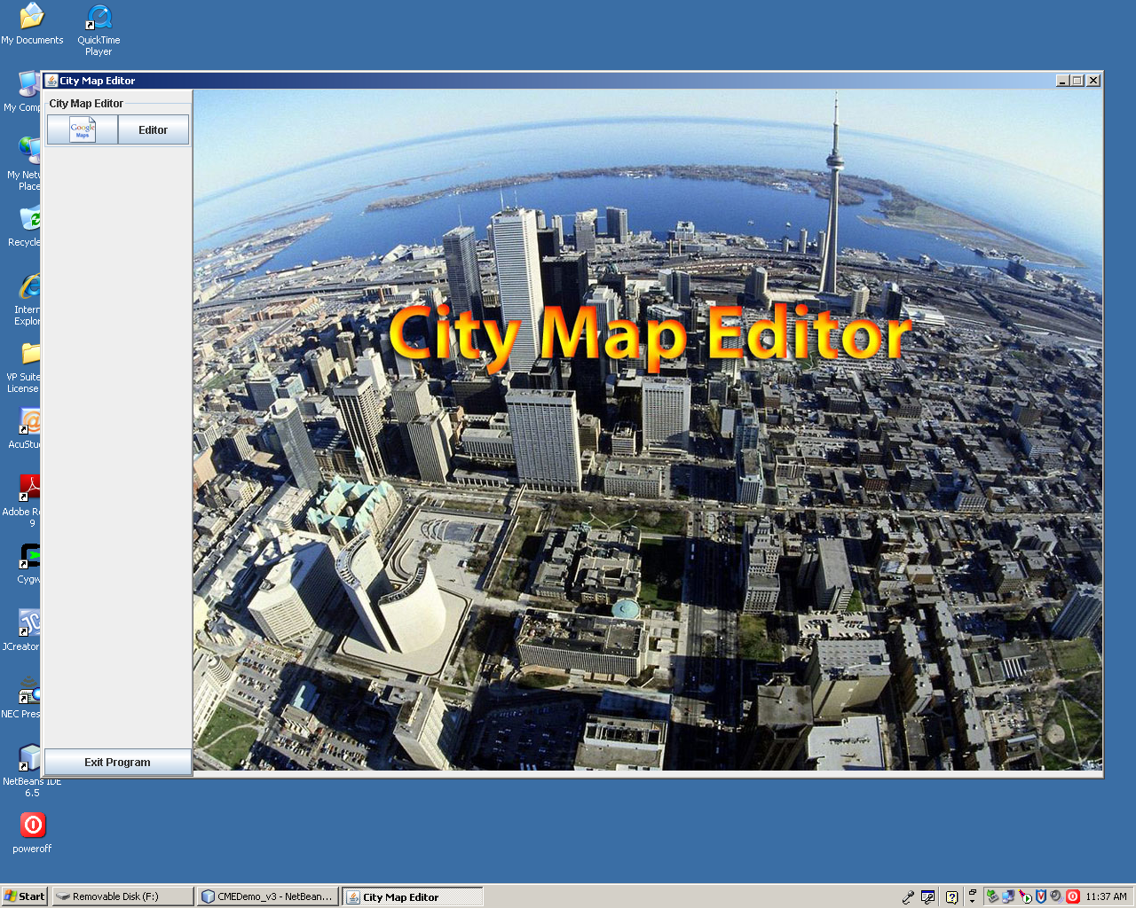

* Once the application is activated, click on the *Editor button* in the City Map Editor panel. User will see the Map local panel appear.

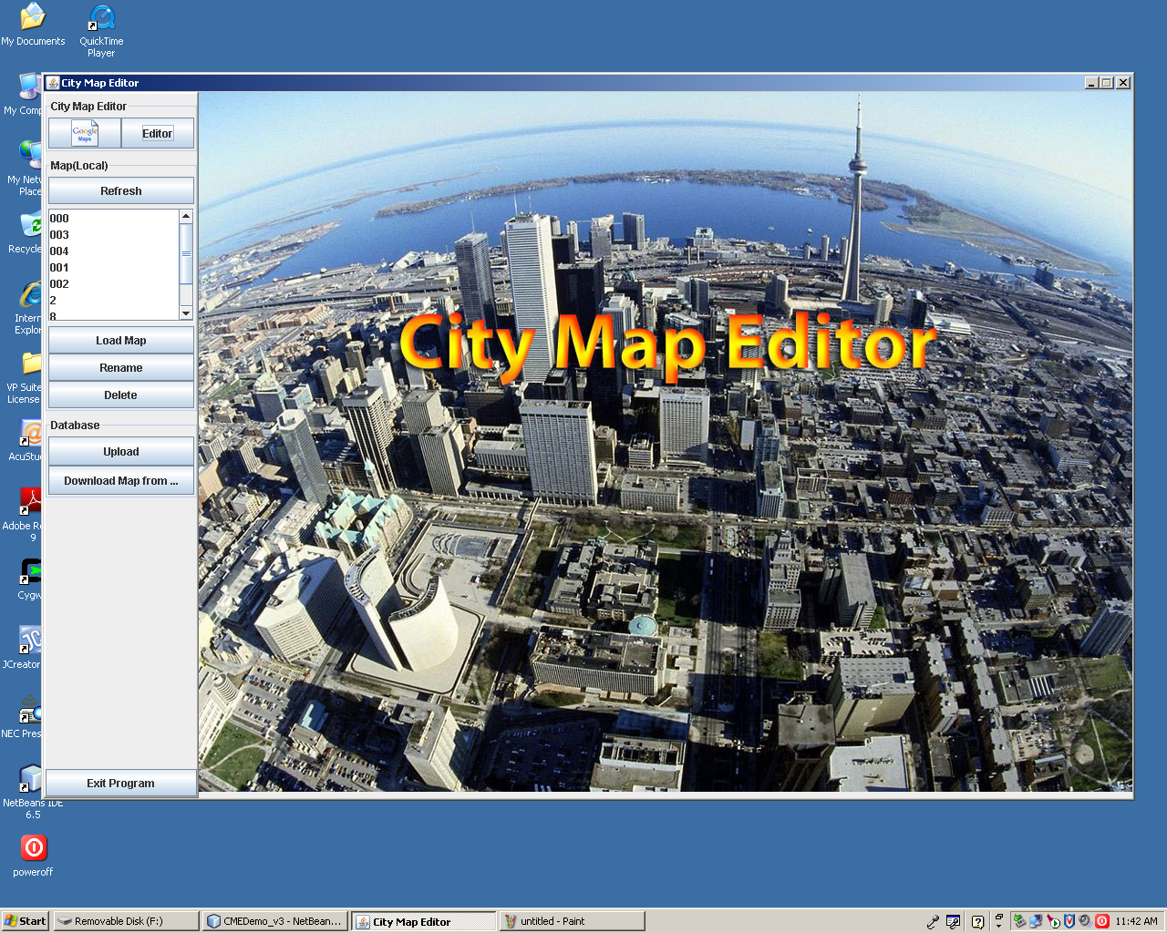

* In the Map local panel listbox, select the map name Joo Koon and click on the Load button. The map will be loaded as shown below. The user wishes to take bus and travel from Joo Koon Circle to Joo Koon Cresent.

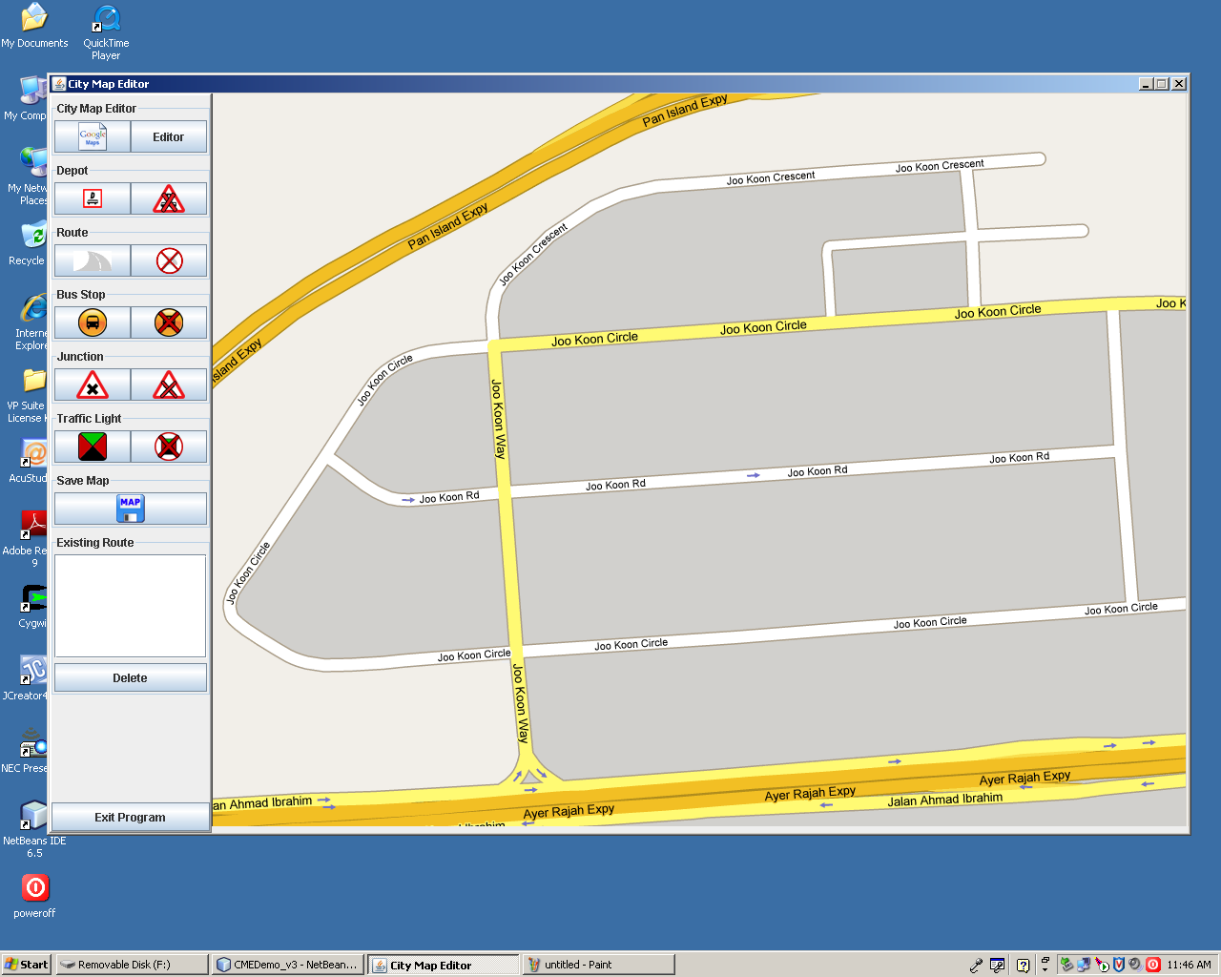

* So firstly, user will specify the bus stops that the bus route will take. Bus stop symbols are added as specified.

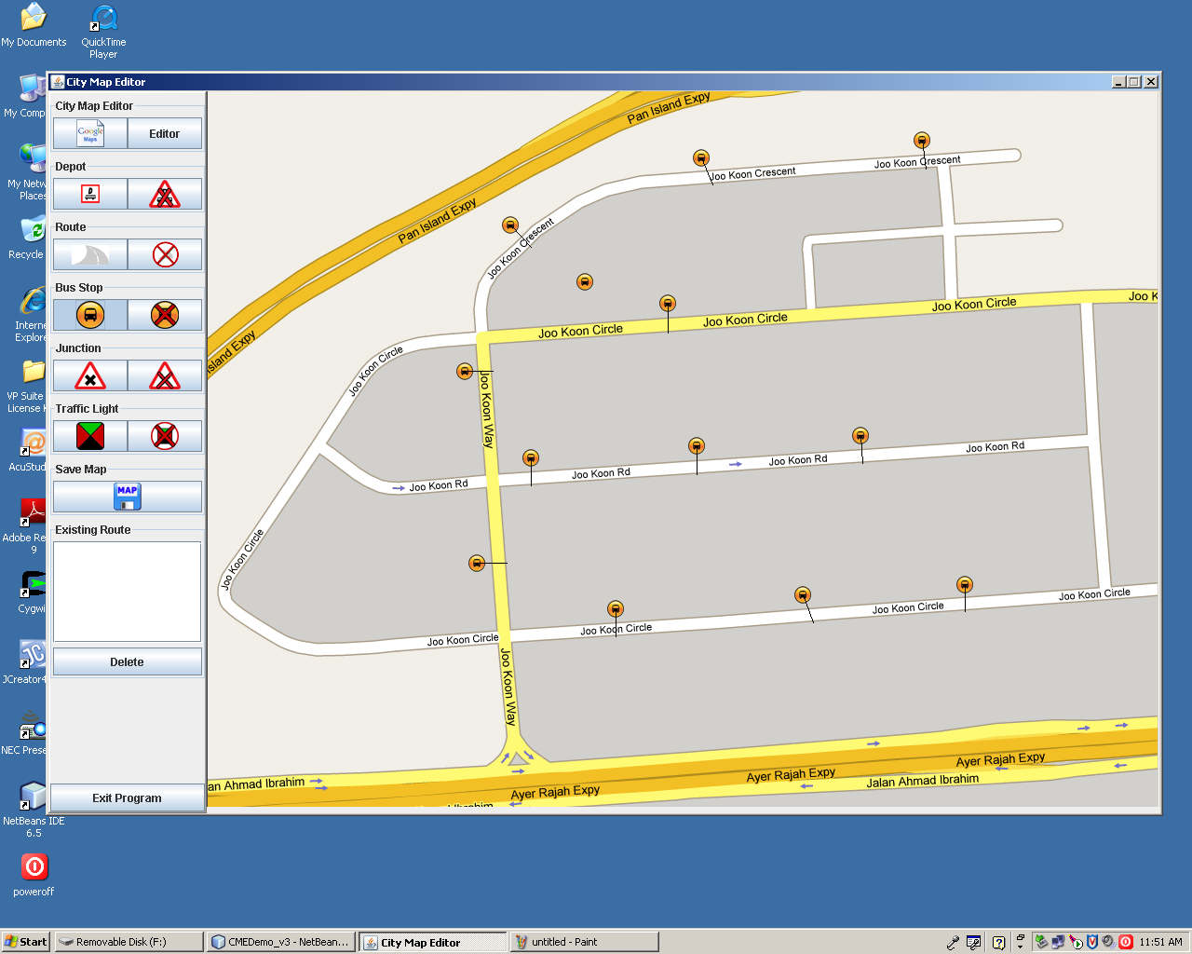

Bus Stops

* After which, the user continues to specify the junctions and traffic lights to help him plan the route.

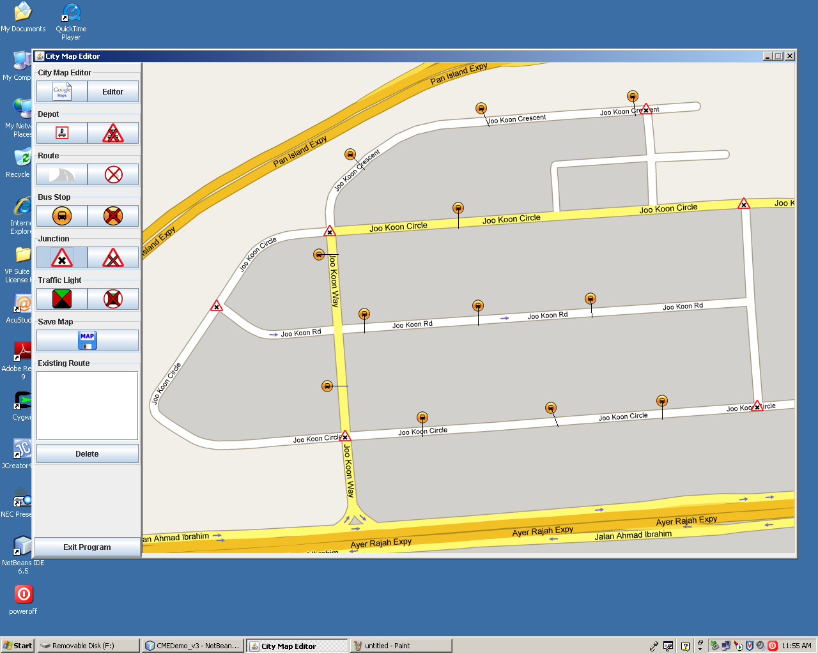

Junctions

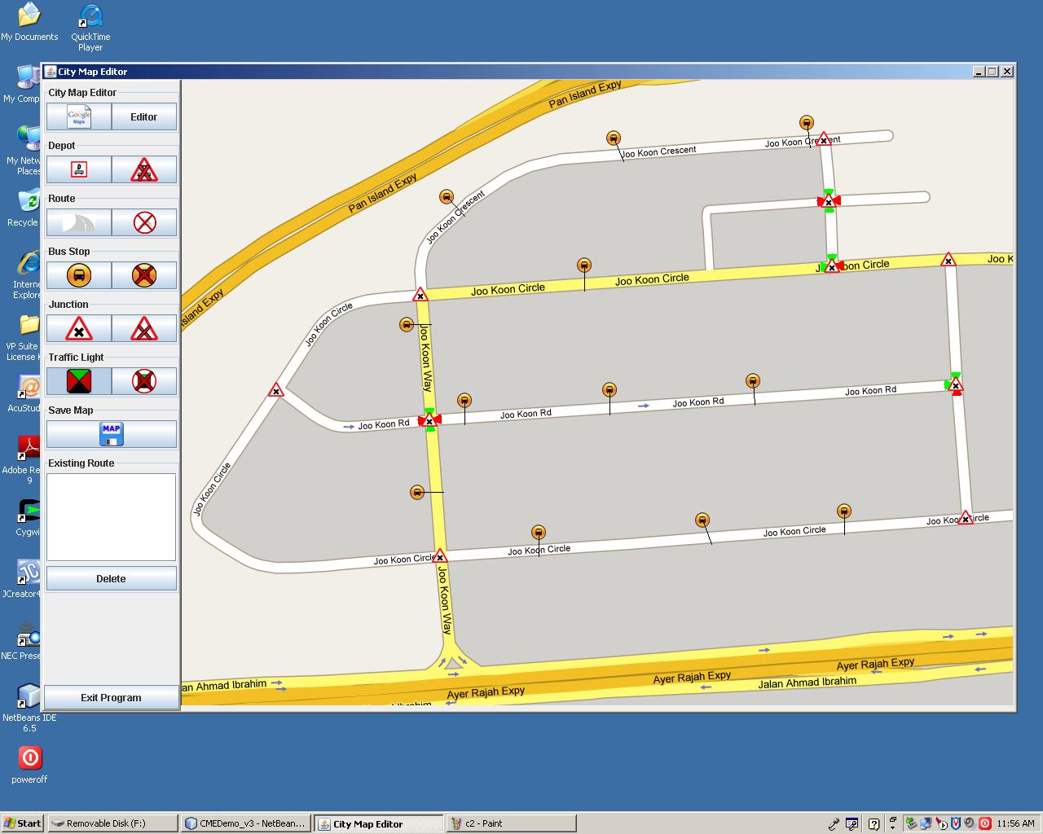

Traffic

Lights

* After adding the map components, the user studies the modified map and is now ready to plan his route, but before that, user must specify the location of the depots first. Click on the Add Depot button.

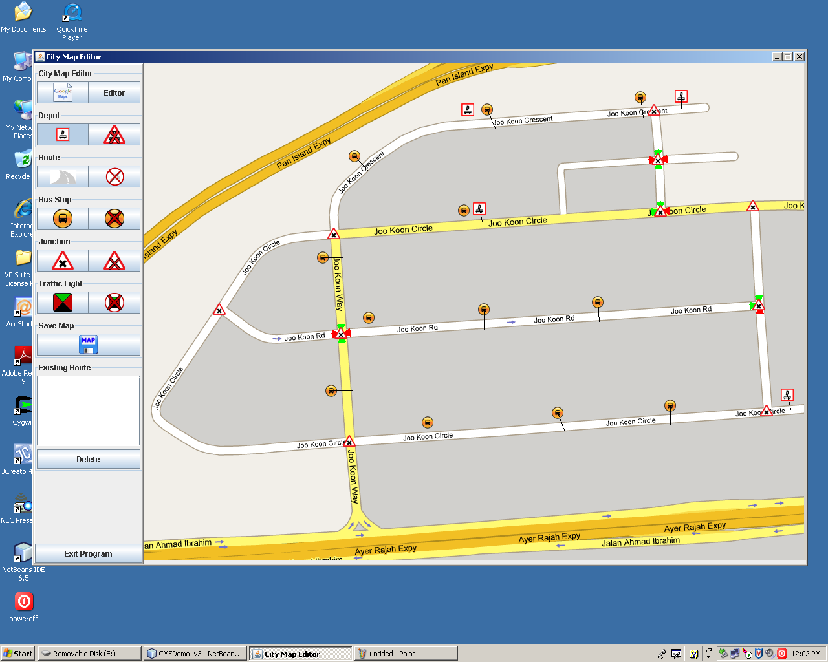

Depot

* However, the user decides to remove 2 of the depots as he only wishes to create one route. So he can make use of the Delete Depot button.

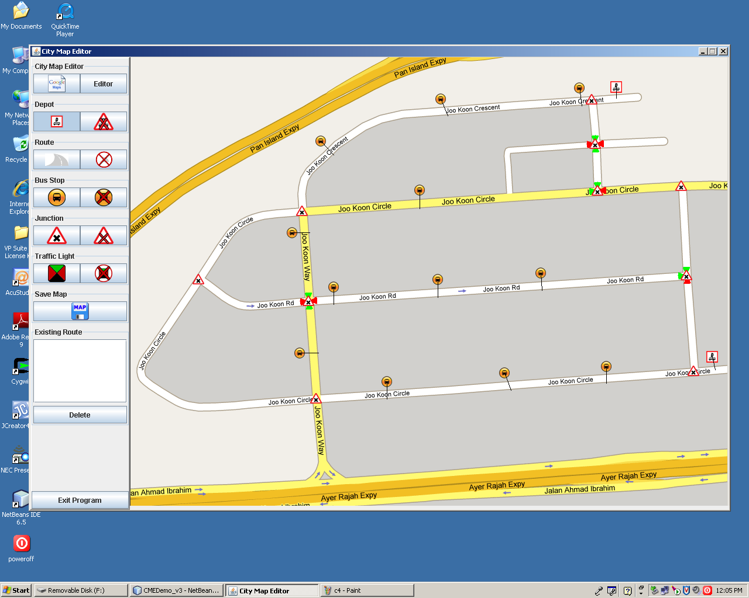

Removed

Depots

* User can now proceed to create the route. Click on Add Route button to begin.

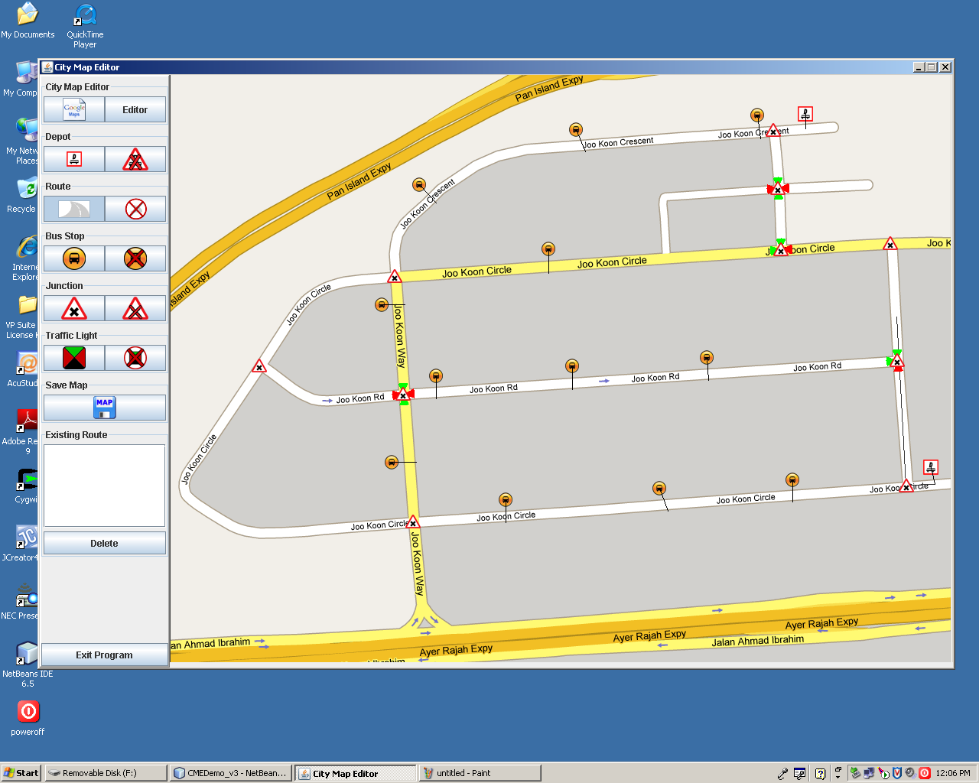

Plotted Route

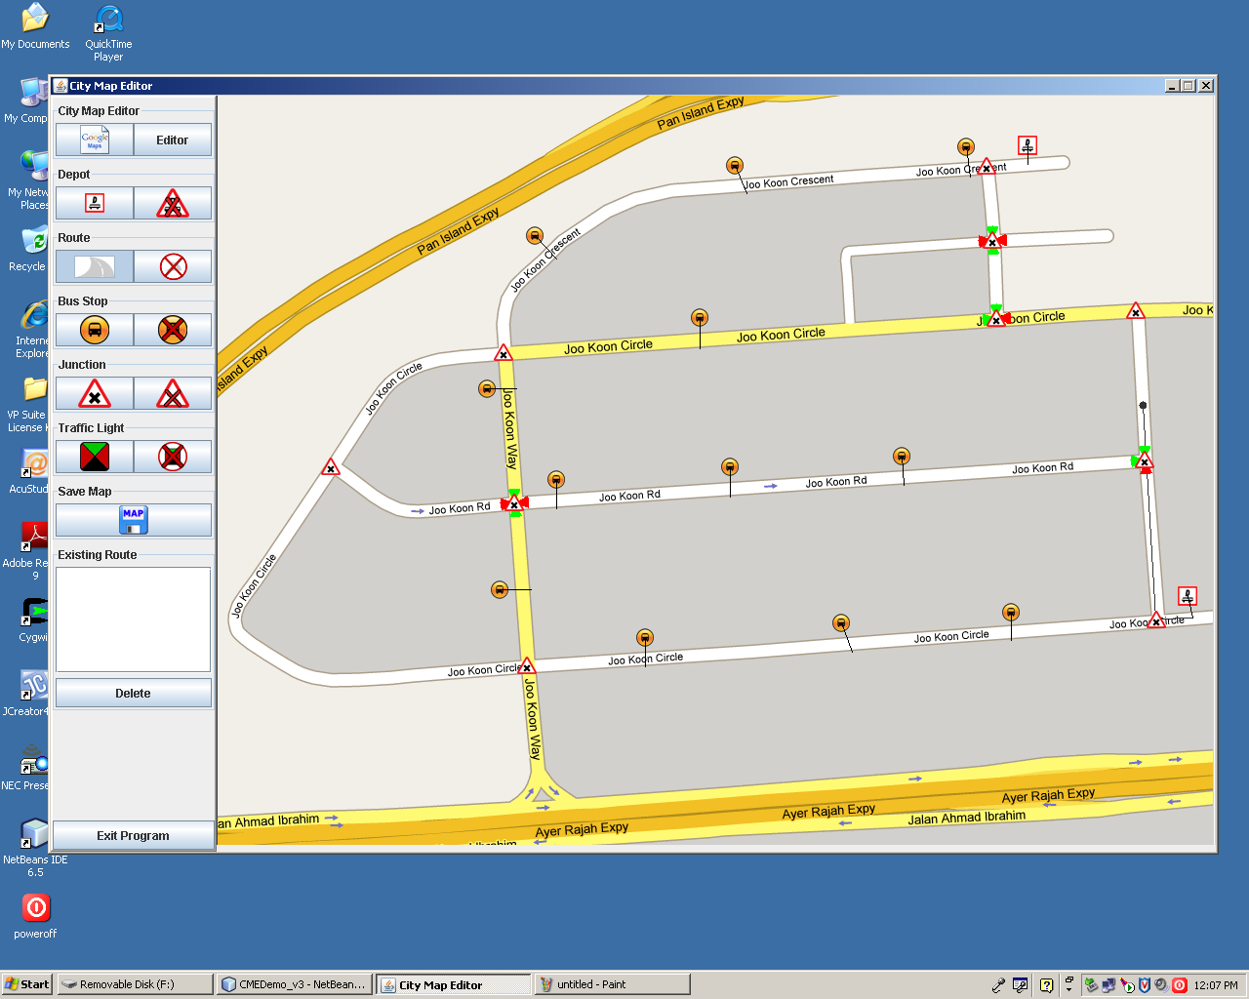

* As user is uncertain of which bus stop should he alight on Joo Koon Cresent, he decides to take the route along the stretch of Joo Koon Cresent which passes through 3 bus stops.

To end the route, click on the depot. A dialog box will prompt the user whether it is the end point for the route. Click the Yes button to proceed.

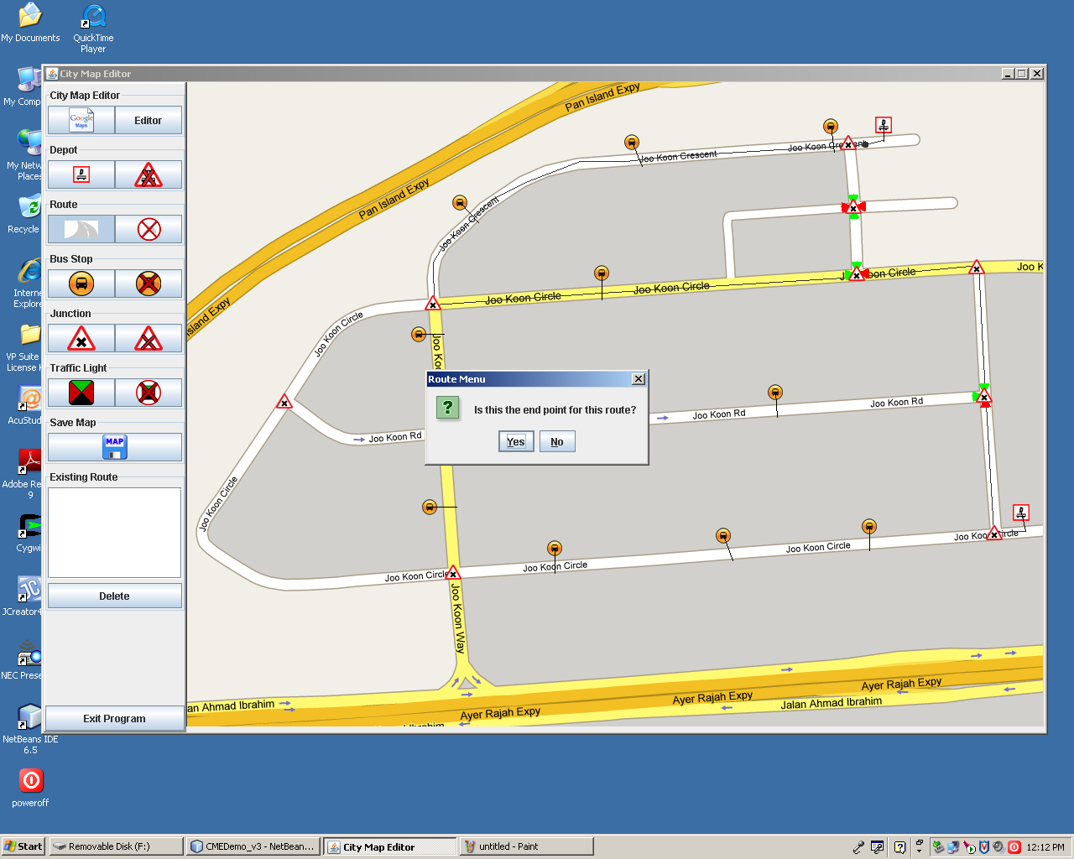

* The confirmed route specified will be thickened for clearer illustration. A dialog will prompt the user to enter the route ID for saving the route.

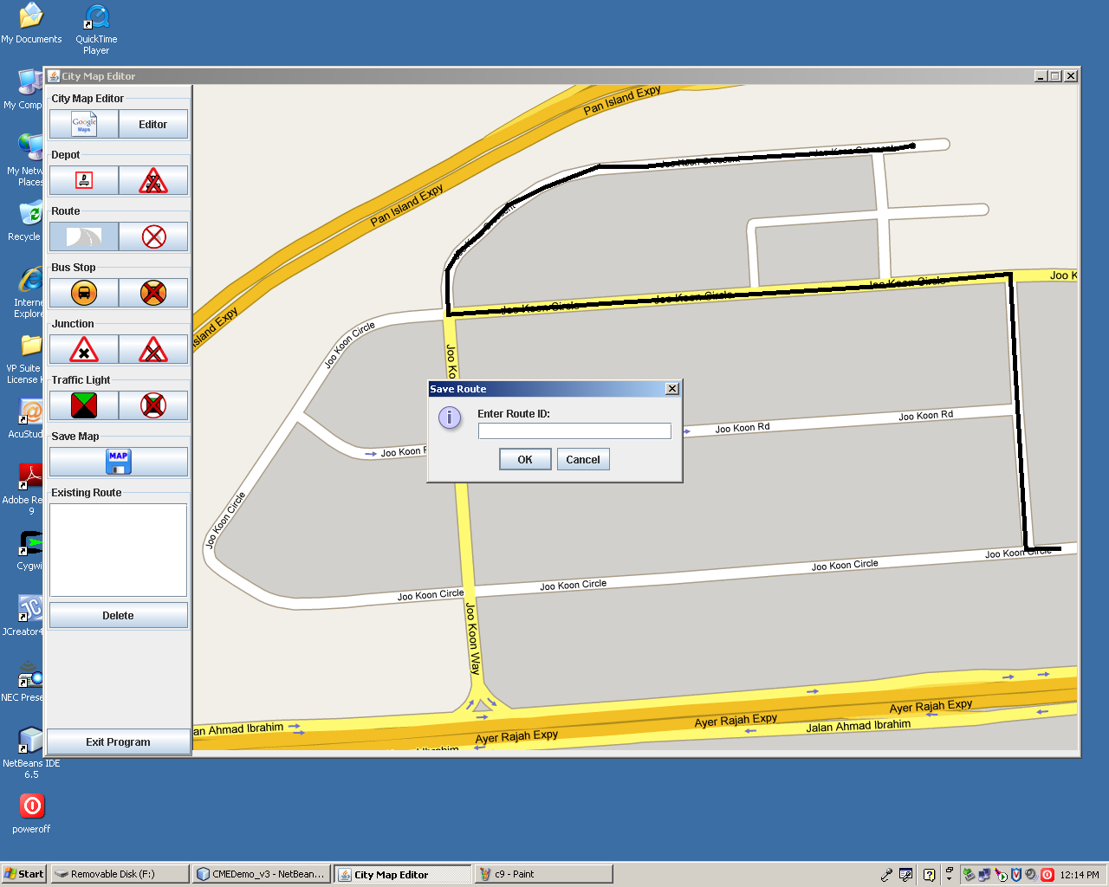

User enters ‘001’ and click on OK button as shown above.

* To view the route plotted, click on the Route ID under the Existing Route panel and the route will reappear on the map.

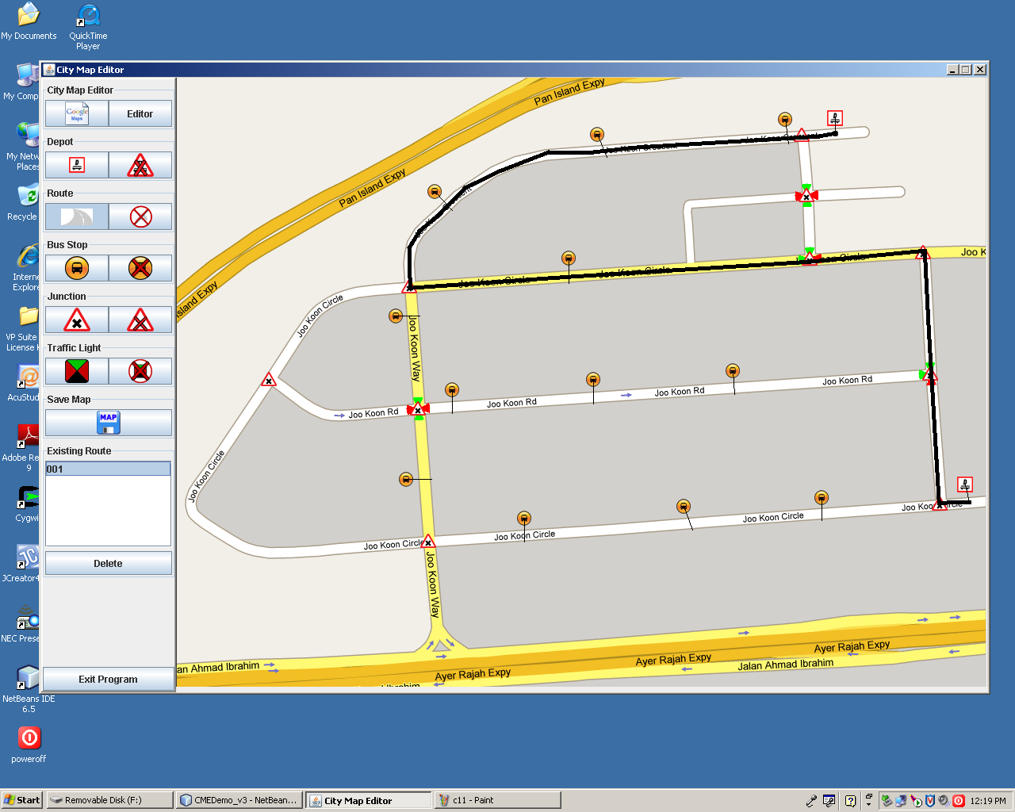

* To save the changes made to the map, click on the Save button.

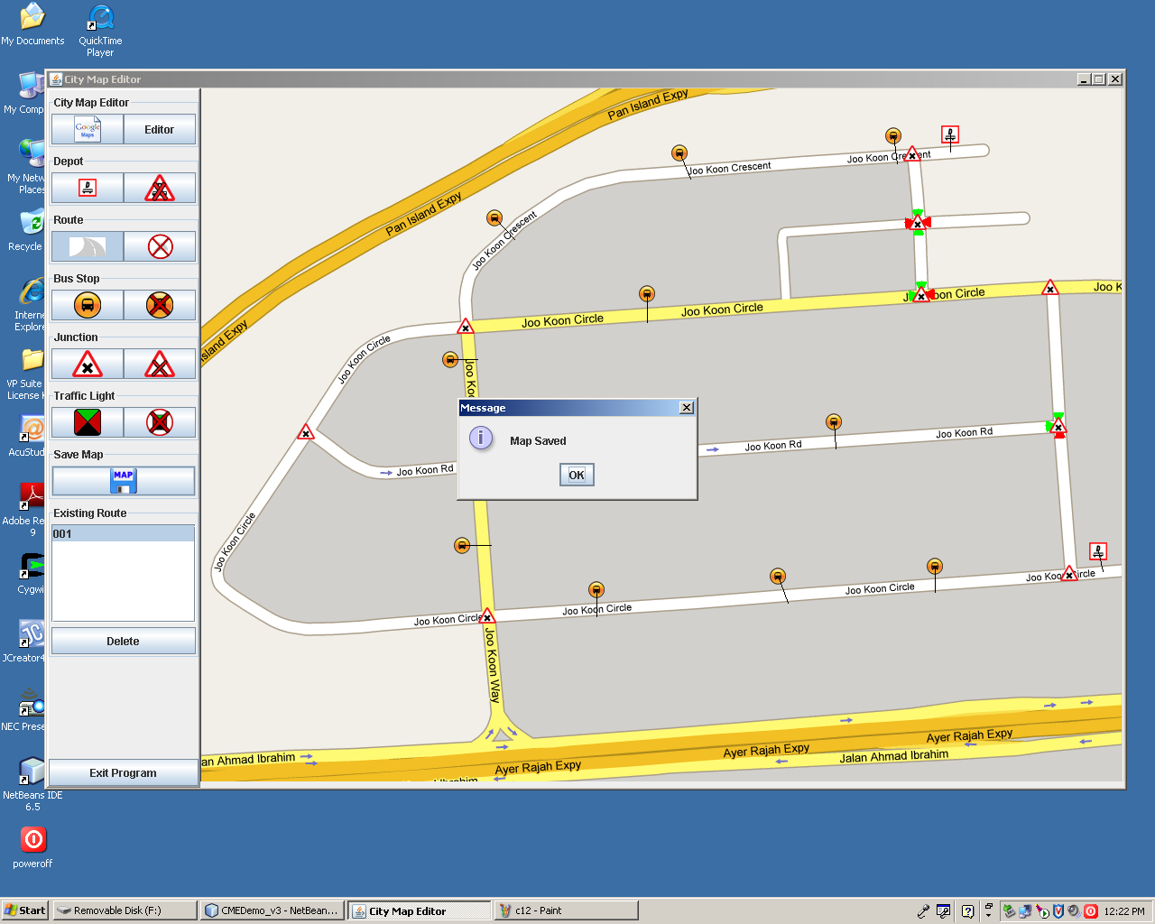

* Saving the changes will take about a minute. A dialog box will appear to confirm that the map has been saved. Click on the OK button.
* User can now click on the Exit Program button to terminate the session. A dialog box will pop out to remind the user to save any modification.

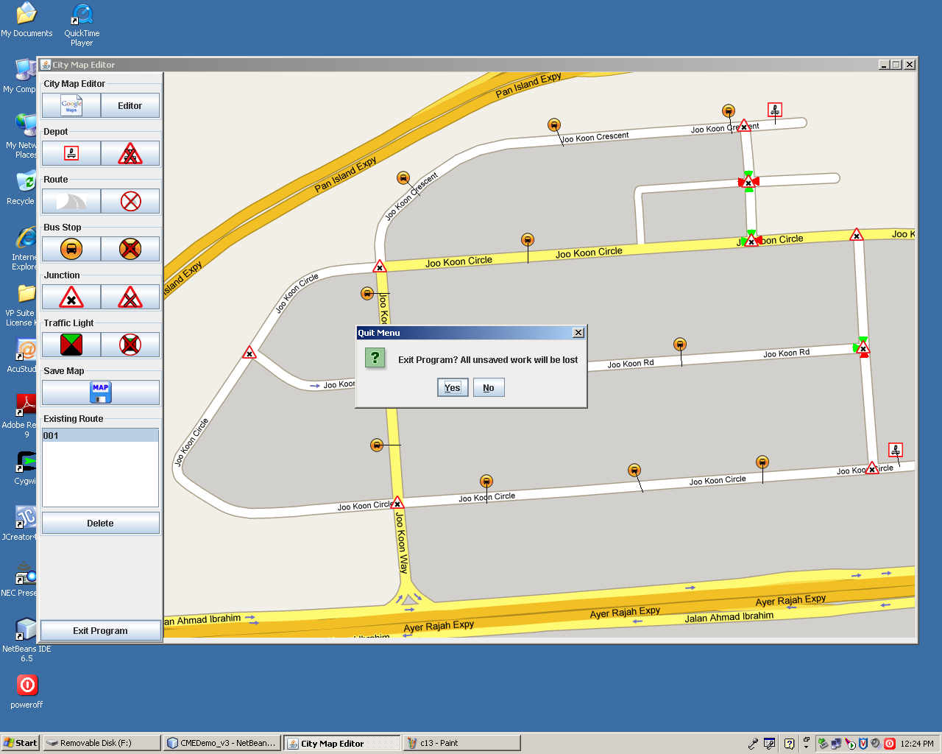

If you have already saved the changes previously, click on the Yes button. If changes are not yet saved, click on the No button to go back to the application.

# 5. Troubleshooting Tips

**Q: Why do I always get to areas of the map that is not my area of interest?**

A: Make sure the name of the area that you type is correct. To ensure the accuracy of the displaying the area of your interest, use the format **Name of the Street > Name of City > Name of Country** when typing in the Google Search Bar. If problem still persist, your area of interest may be just around the area of the map that is displayed. You can move your cursor to your map and drag the map around until you can find the area of your interest.

**Q: Why doesn’t the name of the maps shown on the Map (Local) Panel Text Box after I saved the map?**

A: Click on the refresh button by selecting **Editor > Refresh**. Alternatively, you can exit the program by selecting **Exit Program** button and reload the program and select **Editor > Refresh.** The maps are saved in your PC once you have click on the **Save Map button 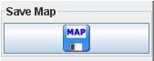.** Therefore, maps will not be deleted even if you exit the program.

**\*Q: Problems encountered during the placing of Depot/Bus Stop/Junction/Traffic Light icons on the map?**

A: Ensure that the icons are placed in the specific location. Example, **Junction icon** should only be placed on junctions of the road, not including Expressways**. Depot** and **Bus Stop icon** should only be placed on the off-road on the map, not on the road, not including Expressways. See “How to Use Map Components”, section 3.

**Q: How do I avoid the situation whereby I have to load all the maps to identify which is the map that I wanted?**

A: Ensure name uniqueness. Example, for two maps of the same area of interest, one with no components placed and one with components placed, instead of having names like “Map 1 and Map 2”, you can name the maps “Map and Map Components”.

**Q: I can’t seems to plot route on the map.**

A: Ensure that at least 2 **Depots** placed on the map and click on the first **Depot** icon to start plotting. To end the route, click on the second **Depot** icon.

**Q: I can’t seems to Upload or Download maps from Database.**

A: Ensure there is internet connection for your PC. If problem still exist, Database might be down. Try again later.